

**Multiwii 2.3 DIY Drone**

**By Ardujimmy**

See more: <https://www.youtube.com/@ArduJimmy/videos>

Rep Github: <https://github.com/ArduJimmy/ArduJimmy-Brushed-QuadX-With-Flysky>

1. **MAIN COMPONENTS:**
2. Arduino Promini 328p 5v
3. AMS1117 3.3v
4. MPU6050 / GY-521
5. Step-up Converter 3.7v to 5v DC
6. Capacitor 100uf 25v/16v/50v
7. 720 Coreless Motor (820 or 8520 is the better)
8. ESC (mosfet si2302 + in5819 + 10K)
9. Propeller 65mm-1mm / 75mm-1mm
10. AWG 28 (it is a must)
11. LiPO Battery 3.7v 45C / 80C
12. **ESC WIRING**

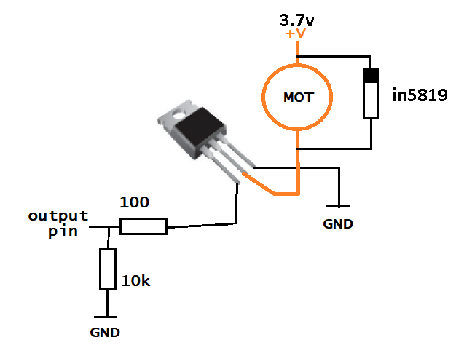

1. **FORM FACTOR (USING ICE CREAM STICK)**

